RHCSA SESSION-2

..

->User is of 3 types:

* Admin…root
* Local….xyz,abc
* Sys…apache,mail,docker

->Vim /etc/shadow

Chage -l root

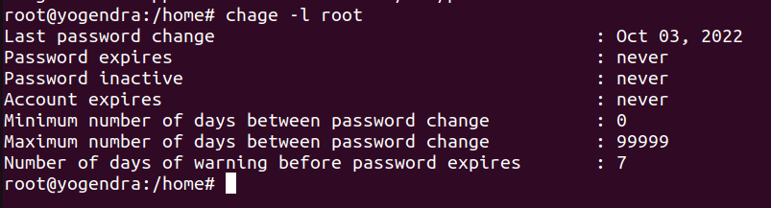

->Home directory in other location:

Useradd ram

Usermod -s /bin/sh ram #shell change

Usermod -d /tmp/ram ram # home location change

Usermod -L ram #user lock not able to login graphically

->Vim /var/log/secure ###information related to user login.

->Admin rights to user

Visudo

Wheel ###to add group in admin privileges

-> id ### to show the IDs

->Controlling files:

| owner | group | other |
| --- | --- | --- |
| r | w | x |
| 4 | 2 | 1 |

Umask

Root–022

User–002

Directory:

| 7 | 7 | 7 |
| --- | --- | --- |
| 0 | 2 | 2 |

File:

| 6 | 6 | 6 |
| --- | --- | --- |
| 0 | 2 | 2 |

->To change the Umask

Vim /etc/profile

->New user uid starts from 1000

*->Special permissions:

* Sticky bit
* Setuid …
* setgid

Setuid, setgid, and the sticky bit can be tough for new and aspiring Linux admins to understand. It's easy enough to do a web search for the basic definitions:

* setuid: a bit that makes an executable run with the privileges of the owner of the file
* setgid: a bit that makes an executable run with the privileges of the group of the file
* sticky bit: a bit set on directories that allows only the owner or root can delete files and subdirectories

->Sticky bit:

Chmod 1777 /filename ## 1 for sticky bit permission

-> mount:

root@yogendra:/home# which mount

/usr/bin/mount

root@yogendra:/home# ll /usr/bin/mount

-rwsr-xr-x 1 root root 47480 Feb 21 2022 /usr/bin/mount*

root@yogendra:/home#

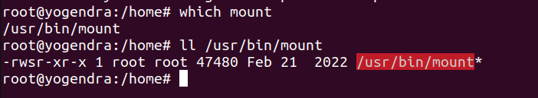

In shadow file there is no permission but we can use it due to attributes

-> lsattr

yogendar@yogendra:/home$ lsattr

--------------e------- ./yogendar

--------------e------- ./file1.txt

--------------e------- ./yogi

--------------e------- ./file1.cpp

--------------e------- ./mariadb.yml

--------------e------- ./file2.txt

--------------e------- ./mariadb

--------------e------- ./ssl

--------------e------- ./checkmd5.md5

Ps -aux |grep file name

Top -c ##command to see all the process **.***Assignment**

Press 1 to see the cpu

PR — priority-total priority =20

Man top

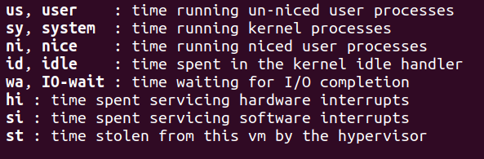

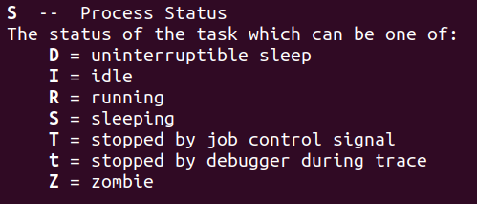

->Two type process:

1. foreground
2. Background

->Sleep command

Ps -ef |grep sleep

*To run command in background

Sleep 10000 &

To run command in foreground

Fg %1

To run command in background

Bg %1

**+- learn\***

**Kill -9 and -15 ……….***Assignment**

->Jobs command will show the background running command in the present terminal

->Killall command_name # to kill the all process of the command

-> w command #show the users login details

->pgrep command ## process grep

->ps -aux command # shows the running process

->Controlling service and daemon:

Mask and unmask

Systemctl list-unit --type=service ## show the service

Loaded– configuration file is processed

Enable – started at boot time

Disable– not started at boot time

Active– means service is running

Exited service # 1 time configure service

->To check the service is active:

Systemctl is-active firewalld.service

**Socket**

**Service**

**Daemon**

->Yum info – package info/ details

->Systemctl list-unit-files –type=service ## show the enabled/disabled service

**Static** means service will automatically enable/disable the service when needed

*********************************************************************************************************